SARVESH KUMAR SINGH

20SCSE2030046

SECTION – 2

Course Name-Object Oriented Programming with Java

Course code-(MCAN1210)

PROGRAM

**Sorting Numbers**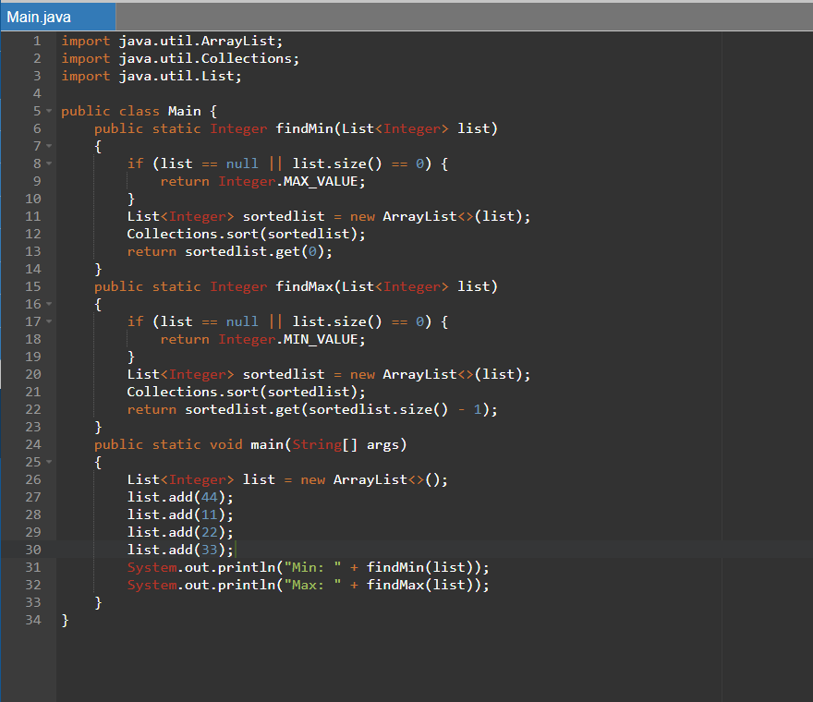

PROGRAM

imporhttps://www.onlinegdb.com/online_java_compiler#editor_1t java.util.ArrayList;

import java.util.Collections;

import java.util.List;

public class Main {

public static Integer findMin(List<Integer> list)

{

if (list == null || list.size() == 0) {

return Integer.MAX_VALUE;

}

List<Integer> sortedlist = new ArrayList<>(list);

Collections.sort(sortedlist);

return sortedlist.get(0);

}

public static Integer findMax(List<Integer> list)

{

if (list == null || list.size() == 0) {

return Integer.MIN_VALUE;

}

List<Integer> sortedlist = new ArrayList<>(list);

Collections.sort(sortedlist);

return sortedlist.get(sortedlist.size() - 1);

}

public static void main(String[] args)

{

List<Integer> list = new ArrayList<>();

list.add(44);

list.add(11);

list.add(22);

list.add(33);

System.out.println("Min: " + findMin(list));

System.out.println("Max: " + findMax(list));

}

}

OUTPUT

